**JavaScript Grid**

UI:

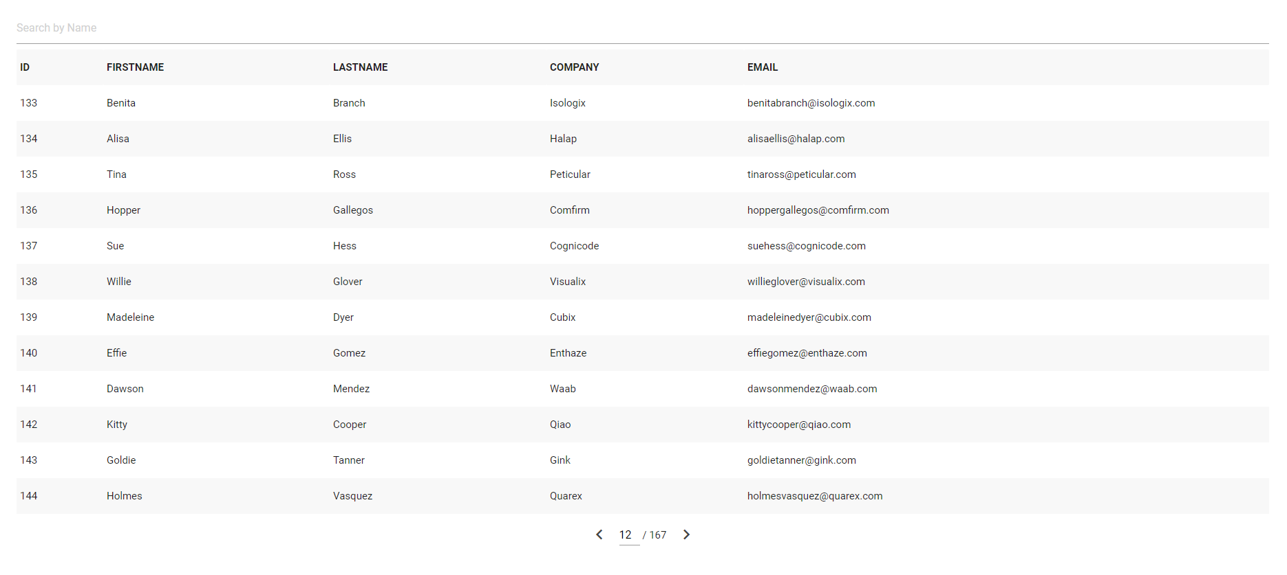

Requirement:

Build a grid layout dynamically that support search, pagination and sorting in pure JavaScript without any third party plugins. Any CSS framework can be used for styling the grid.

Note:

* Search by Name should search both first name and last name data.
* Should display only 12 rows per page
* When search results 0 records, “No results found” message should be displayed below the table header.

Data Source:

<https://emp-api-rakesh.herokuapp.com/employees>

Demo:

<https://drive.google.com/file/d/1xC8_Kj35LMKk_VjQWQe6mpCul7F3a9u3/view?usp=sharing>

Output:

1. PR from a public github repo for review.
2. Calculator app link hosted using github pages.